Arduino-Based Real Time Air Quality and Pollution Monitoring System

Abstract—Now-a-days air pollution is one of the most important concern of the world. Air pollution may evolve from anthropogenic or natural sources. Air pollutants of atmospheric substances like CO, CO2, SO2, NO2, and O3 suspended particulate matter (SPM), repairable suspended particulate matter (RSPM), and volatile organic compounds (VOCs) have a great effect on the people health. Most of the major cities in developing countries and most cities of the developed countries are suffering from it. Thus to develop a real time air quality and pollution monitoring system is critical. We have developed an arduino based air pollution detector which combined a small-sized, minimum-cost sensor to an arduino microcontroller unit. The advantages of the detector, have a reliable stability, rapid response recovery and long-life features. It is affordable, user-friendly, low-cost and minimum-power requirement hardware which is appropriate for mobile measurement, as well as comprehensible data collection. It has a processing software able to analyze, collected quality data with high precision. Simple instrument which can be commercially utilized. Keywords- Air pollution, ardunio, gas sensor, anthropogenic, atmosphere.

INTRODUCTION:
Air pollution is the presence of extra unwanted biological molecules, particulates or other harmful things into the earth atmosphere. It is a major cause of infections, allergies, and eventually reasons of death to some peoples. It also harms to other existing creatures like that animals as well as food crops, or the ecological or built environment. They are also accountable for various kinds respiratory infections (like asthma), causes of different types of cancer in individuals, if they are unprotected to these toxins or chemicals for long period of time. For example, carbon monoxide (CO) is extremely poisonous to people as it may happen serious asphyxiation, headaches because of the composition of carboxy-hemoglobin and thus a reason of death if unprotected for a long time. The world health organization (WHO) in 2014 approximated that 7 million people deaths worldwide because of air pollution. The similar approximation roughly equaled by the International Energy Agency (IEA) also. These chemicals or pollutants are also responsible for various environmental calamities like acid rain and depletion of ozone layer. Because of a number of anthropogenic actions, air pollution is on the growth and its controlling is of significant importance to alleviate particular actions to limit it. In the past, the air quality measuring sensors were very big, non-portable and expensive. Presently, most air pollution sensors developed on five most common air pollutants viz. nitrous oxide, carbon monoxide, ozone, sulfur dioxide and particulate matter. In today’s world, air pollution and quality monitoring are really vital as it has a great effect on human health. The developed air-quality measurement sensor can identify and observe the incidence of air pollution in the adjacent areas. It can be employed for both indoor and outdoor. With the help of future technological improvements, these sensors will become cheaper and more common, inexpensive, portable airquality sensors which can be wearable by people to observe the local air quality.

Required Components:
- MQ135 Gas sensor
- Arduino Uno
- Wi-Fi module ESP8266
- 16X2 LCD
- Breadboard
- 10K potentiometer
- 1K ohm resistors
- 220 ohm resistor
- Buzzer

Circuit Diagram and Explanation:
First of all we will connect the ESP8266 with the Arduino. ESP8266 runs on 3.3V and if you will give it 5V from the Arduino then it won’t work properly and it may get damage. Connect the VCC and the CH_PD to the 3.3V pin of Arduino. The RX pin of ESP8266 works on 3.3V and it will not communicate with the Arduino when we will connect it directly to the Arduino. So, we will have to make a voltage divider for it which will convert the 5V into 3.3V. This can be done by connecting three resistors in series like we did in the circuit. Connect the TX pin of the ESP8266 to the pin 10 of the Arduino and the RX pin of the esp8266 to the pin 9 of Arduino through the resistors.
ESP8266 Wi-Fi module gives your projects access to Wi-Fi or internet. It is a very cheap device and make your projects very powerful. It can communicate with any microcontroller and it is the most leading devices in the IOT platform. Learn more about using ESP8266 with Arduino here.
Then we will connect the MQ135 sensor with the Arduino. Connect the VCC and the ground pin of the sensor to the 5V and ground of the Arduino and the Analog pin of sensor to the A0 of the Arduino.
Connect a buzzer to the pin 8 of the Arduino which will start to beep when the condition becomes true.

- Connect pin 1 (VEE) to the ground.
- Connect pin 2 (VDD or VCC) to the 5V.
- Connect pin 3 (V0) to the middle pin of the 10K potentiometer and connect the other two ends of the potentiometer to the VCC and the GND. The potentiometer is used to control the screen contrast of the LCD. Potentiometer of values other than 10K will work too.
- Connect pin 4 (RS) to the pin 12 of the Arduino.
- Connect pin 5 (Read/Write) to the ground of Arduino. This pin is not often used so we will connect it to the ground.
- Connect pin 6 (E) to the pin 11 of the Arduino. The RS and E pin are the control pins which are used to send data and characters.
- The following four pins are data pins which are used to communicate with the Arduino.
- Connect pin 11 (D4) to pin 5 of Arduino.
- Connect pin 12 (D5) to pin 4 of Arduino.
- Connect pin 13 (D6) to pin 3 of Arduino.
- Connect pin 14 (D7) to pin 2 of Arduino.
- Connect pin 15 to the VCC through the 220 ohm resistor. The resistor will be used to set the back light brightness. Larger values will make the back light much more darker.
- Connect pin 16 to the Ground.
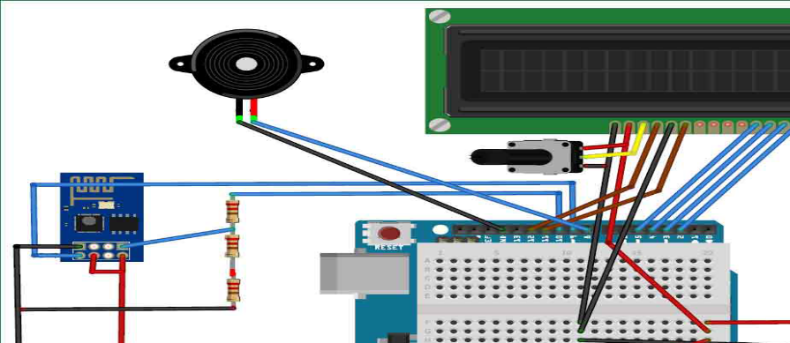

Working Explanation:
The MQ135 sensor can sense NH3, NOx, alcohol, Benzene, smoke, CO2 and some other gases, so it is perfect gas sensor for our Air Quality Monitoring Project. When we will connect it to Arduino then it will sense the gases, and we will get the Pollution level in PPM (parts per million). MQ135 gas sensor gives the output in form of voltage levels and we need to convert it into PPM. So for converting the output in PPM, here we have used a library for MQ135 sensor, it is explained in detail in “Code Explanation” section below.
Sensor was giving us value of 90 when there was no gas near it and the safe level of air quality is 350 PPM and it should not exceed 1000 PPM. When it exceeds the limit of 1000 PPM, then it starts cause Headaches, sleepiness and stagnant, stale, stuffy air and if exceeds beyond 2000 PPM then it can cause increased heart rate and many other diseases.
When the value will be less than 1000 PPM, then the LCD and webpage will display “Fresh Air”. Whenever the value will increase 1000 PPM, then the buzzer will start beeping and the LCD and webpage will display “Poor Air, Open Windows”. If it will increase 2000 then the buzzer will keep beeping and the LCD and webpage will display “Danger! Move to fresh Air”.

Code Explanation:
Before beginning the coding for this project, we need to first Calibrate the MQ135 Gas sensor. There are lots of calculations involved in converting the output of sensor into PPM value, we have done this calculation before in our previous Smoke Detector project. But here we are using the Library for MQ135,
MQ135 gasSensor = MQ135(A0);
float air_quality = gasSensor.getPPM();
#include "MQ135.h"
void setup (){
Serial.begin (9600);
}
void loop() {
MQ135 gasSensor = MQ135(A0); // Attach sensor to pin A0
float rzero = gasSensor.getRZero();
Serial.println (rzero);
delay(1000);
}
After getting the RZERO value. Put the RZERO value in the library file you downloaded "MQ135.h"
In the code, first of all we have defined the libraries and the variables for the Gas sensor and the LCD. By using the Software Serial Library, we can make any digital pin as TX and RX pin. In this code, we have made Pin 9 as the RX pin and the pin 10 as the TX pin for the ESP8266. Then we have included the library for the LCD and have defined the pins for the same. We have also defined two more variables: one for the sensor analog pin and other for storing air_quality value.
#include <SoftwareSerial.h>
#define DEBUG true
SoftwareSerial esp8266(9,10);
#include <LiquidCrystal.h>
LiquidCrystal lcd(12,11, 5, 4, 3, 2);
const int sensorPin= 0;
int air_quality;
Then we will declare the pin 8 as the output pin where we have connected the buzzer. lcd.begin(16,2) command will start the LCD to receive data and then we will set the cursor to first line and will print the ‘circuitdigest’. Then we will set the cursor on the second line and will print ‘Sensor Warming’.
pinMode(8, OUTPUT);
lcd.begin(16,2);
lcd.setCursor (0,0);
lcd.print ("circuitdigest ");
lcd.setCursor (0,1);
lcd.print ("Sensor Warming ");
delay(1000);
Then we will set the baud rate for the serial communication. Different ESP’s have different baud rates so write it according to your ESP’s baud rate. Then we will send the commands to set the ESP to communicate with the Arduino and show the IP address on the serial monitor.
Serial.begin(115200);
esp8266.begin(115200);
sendData("AT+RST\r\n",2000,DEBUG);
sendData("AT+CWMODE=2\r\n",1000,DEBUG);
sendData("AT+CIFSR\r\n",1000,DEBUG);
sendData("AT+CIPMUair_quality=1\r\n",1000,DEBUG);
sendData("AT+CIPSERVER=1,80\r\n",1000,DEBUG);
pinMode(sensorPin, INPUT);
lcd.clear();
For printing the output on the webpage in web browser, we will have to use HTML programming. So, we have created a string named webpage and stored the output in it. We are subtracting 48 from the output because the read() function returns the ASCII decimal value and the first decimal number which is 0 starts at 48.
if(esp8266.available())
{
if(esp8266.find("+IPD,"))
{
delay(1000);
int connectionId = esp8266.read()-48;
String webpage = "<h1>IOT Air Pollution Monitoring System</h1>";
webpage += "<p><h2>";
webpage+= " Air Quality is ";
webpage+= air_quality;
webpage+=" PPM";
webpage += "<p>";
The following code will call a function named sendData and will send the data & message strings to the webpage to show.
sendData(cipSend,1000,DEBUG);
sendData(webpage,1000,DEBUG);

cipSend = "AT+CIPSEND=";
cipSend += connectionId;
cipSend += ",";
cipSend +=webpage.length();
cipSend +="\r\n";
The following code will print the data on the LCD. We have applied various conditions for checking air quality, and LCD will print the messages according to conditions and buzzer will also beep if the pollution goes beyond 1000 PPM.
lcd.setCursor (0, 0);
lcd.print ("Air Quality is ");
lcd.print (air_quality);
lcd.print (" PPM ");
lcd.setCursor (0,1);
if (air_quality<=1000)
{
lcd.print("Fresh Air");
digitalWrite(8, LOW);
Finally the below function will send and show the data on the webpage. The data we stored in string named ‘webpage’ will be saved in string named ‘command’. The ESP will then read the character one by one from the ‘command’ and will print it on the webpage.
String sendData(String command, const int timeout, boolean debug)
{
String response = "";
esp8266.print(command); // send the read character to the esp8266
long int time = millis();
while( (time+timeout) > millis())
{
while(esp8266.available())
{
// The esp has data so display its output to the serial window
char c = esp8266.read(); // read the next character.
response+=c;
}
}
if(debug)
{
Serial.print(response);
}
return response;
}

Testing and Output of the Project:
Before uploading the code, make sure that you are connected to the Wi-Fi of your ESP8266 device. After uploading, open the serial monitor and it will show the IP address like shown below.
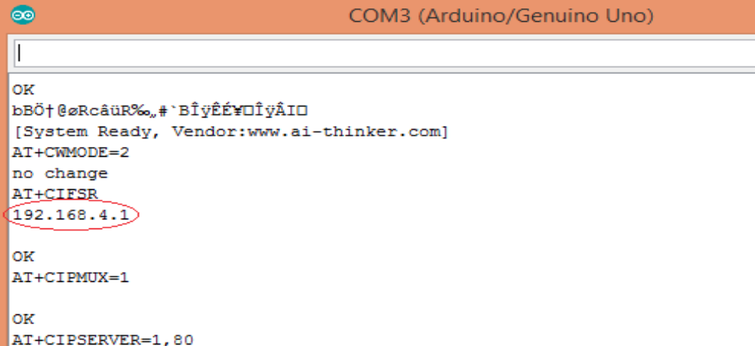
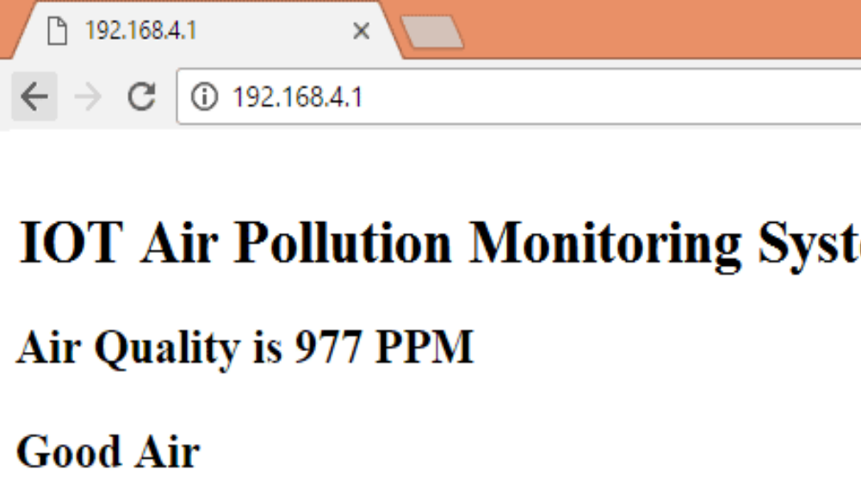
Type this IP address in your browser, it will show you the output as shown below. You will have to refresh the page again if you want to see the current Air Quality Value in PPM.
We have setup a local server to demonstrate its working, you can check the Video below. But to monitor the air quality from anywhere in the world, you need to forward the port 80 (used for HTTP or internet) to your local or private IP address (192.168*) of you device. After port forwarding all the incoming connections will be forwarded to this local address and you can open above shown webpage by just entering the public IP address of your internet from anywhere. You can forward the port by logging into your router (192.168.1.1) and find the option to setup the port forwarding.

Code:
#include "MQ135.h"

#include <SoftwareSerial.h>

#define DEBUG true

SoftwareSerial esp8266(9,10); // This makes pin 9 of Arduino as RX pin and pin 10 of Arduino as the TX pin

const int sensorPin= 0;

int air_quality;

#include <LiquidCrystal.h>

LiquidCrystal lcd(12,11, 5, 4, 3, 2);
void setup() {

pinMode(8, OUTPUT);

lcd.begin(16,2);

lcd.setCursor (0,0);

lcd.print ("circuitdigest ");

lcd.setCursor (0,1);

lcd.print ("Sensor Warming ");

delay(1000);

Serial.begin(115200);

esp8266.begin(115200); // your esp's baud rate might be different

sendData("AT+RST\r\n",2000,DEBUG); // reset module

sendData("AT+CWMODE=2\r\n",1000,DEBUG); // configure as access point
sendData("AT+CIFSR\r\n",1000,DEBUG); // get ip address

sendData("AT+CIPMUair_quality=1\r\n",1000,DEBUG); // configure for multiple connections

sendData("AT+CIPSERVER=1,80\r\n",1000,DEBUG); // turn on server on port 80

pinMode(sensorPin, INPUT);//Gas sensor will be an input to the arduino

lcd.clear();

}
void loop() {
MQ135 gasSensor = MQ135(A0);

float air_quality = gasSensor.getPPM();
if(esp8266.available()) // check if the esp is sending a message

{

if(esp8266.find("+IPD,"))

{

delay(1000);

int connectionId = esp8266.read()-48; /* We are subtracting 48 from the output because the read() function returns the ASCII decimal value and the first decimal number which is 0 starts at 48*/

String webpage = "<h1>IOT Air Pollution Monitoring System</h1>";

webpage += "<p><h2>";

webpage+= " Air Quality is ";

webpage+= air_quality;

webpage+=" PPM";

webpage += "<p>";

if (air_quality<=1000)

{

webpage+= "Fresh Air";

}

else if(air_quality<=2000 && air_quality>=1000)

{

webpage+= "Poor Air";

}
else if (air_quality>=2000 )

{

webpage+= "Danger! Move to Fresh Air";

}
webpage += "</h2></p></body>";

String cipSend = "AT+CIPSEND=";

cipSend += connectionId;

cipSend += ",";

cipSend +=webpage.length();

cipSend +="\r\n";

sendData(cipSend,1000,DEBUG);

sendData(webpage,1000,DEBUG);

cipSend = "AT+CIPSEND=";

cipSend += connectionId;

cipSend += ",";

cipSend +=webpage.length();

cipSend +="\r\n";

String closeCommand = "AT+CIPCLOSE=";

closeCommand+=connectionId; // append connection id

closeCommand+="\r\n";

sendData(closeCommand,3000,DEBUG);

}

}
lcd.setCursor (0, 0);

lcd.print ("Air Quality is ");

lcd.print (air_quality);

lcd.print (" PPM ");

lcd.setCursor (0,1);

if (air_quality<=1000)

{

lcd.print("Fresh Air");

digitalWrite(8, LOW);

}

else if( air_quality>=1000 && air_quality<=2000 )

{

lcd.print("Poor Air, Open Windows");

digitalWrite(8, HIGH );

}

else if (air_quality>=2000 )

{

lcd.print("Danger! Move to Fresh Air");

digitalWrite(8, HIGH); // turn the LED on

}

lcd.scrollDisplayLeft();

delay(1000);

}

String sendData(String command, const int timeout, boolean debug)

{

String response = "";

esp8266.print(command); // send the read character to the esp8266

long int time = millis();

while( (time+timeout) > millis())

{

while(esp8266.available())

{

// The esp has data so display its output to the serial window

char c = esp8266.read(); // read the next character.

response+=c;

}
}

if(debug)

{

Serial.print(response);

}

return response;

}
Conclusion:
After this tutorial, you can develop your own Air Monitoring and Alert System using the MQ-135 sensor and Arduino Uno board.
I hope you found this tutorial informative. If you did, please share it with a friend who likes electronics and making things!

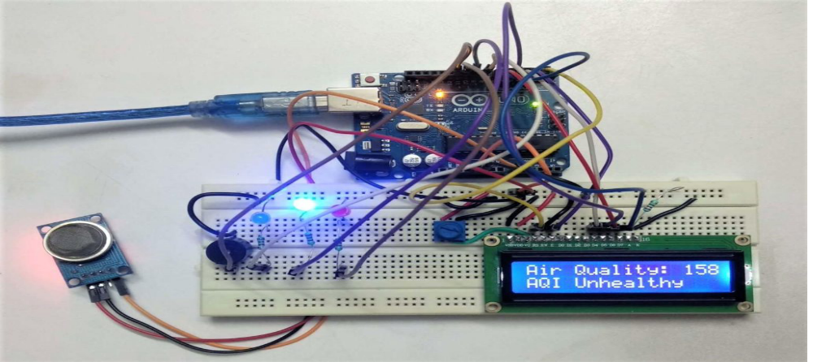
Team members:
1. Rithvik Abinav K R (112821104054)
2.Sasi Kumar D (112821104308)
3.Chennavaram Dhanush (112821104701)
4.Prem Sai J (112821104051)
5.Shaik Imran K (112821104064)

